**Installation Aspen 8.8 in Micro Soft Window 10**

1. Run the Setup “AspenONE Installer” and click on the “Install aspenONE products”

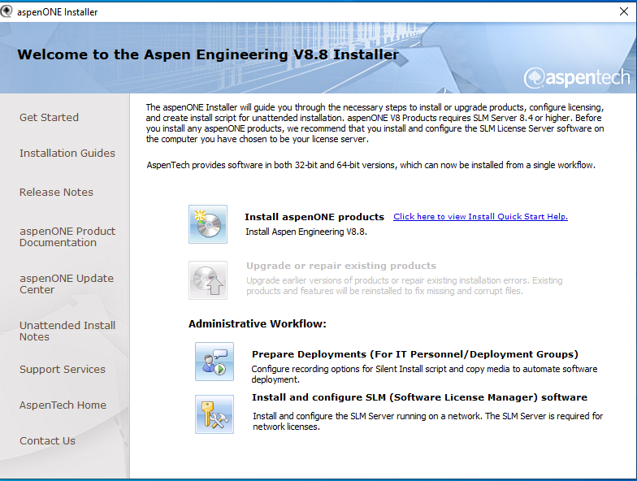

1. Check “I Accept the license agreement” and Click “Next”

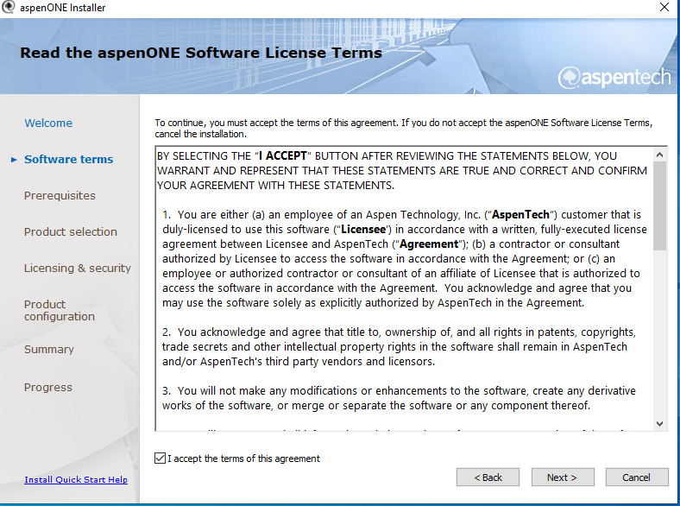

1. Choose the “aspenONE products you want to install will appear, accept the default selection

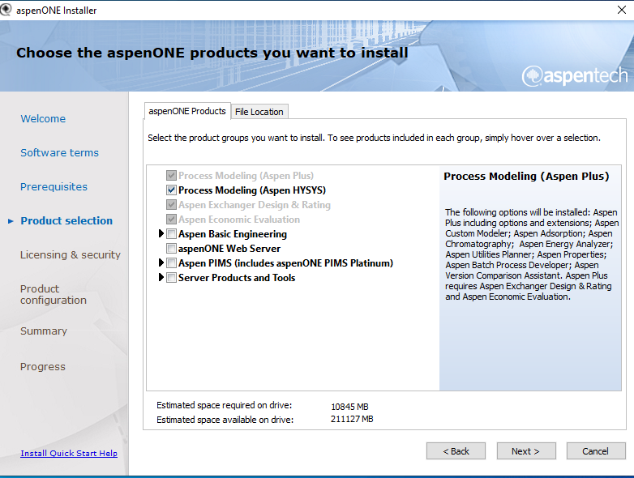

1. Click the file location (Keep it to default) and Click on the “Next” button.

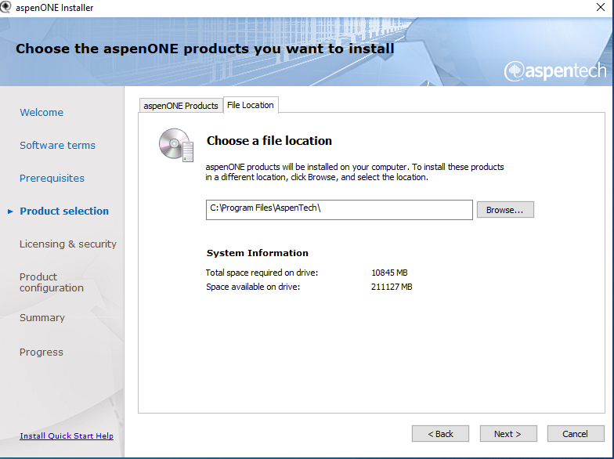

1. Enter the “license Server”. Click on the “Add Server” Button. (License Server IP is 172.31.1.12). and click on the “Next” Button

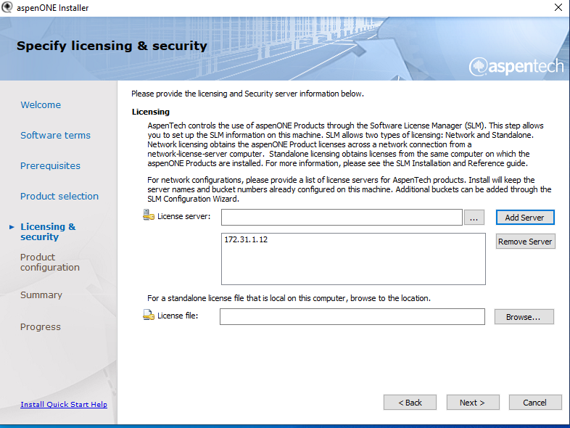

1. Leave blank “aspenONE drive Configuration (Optional)and click on the “Next” button.

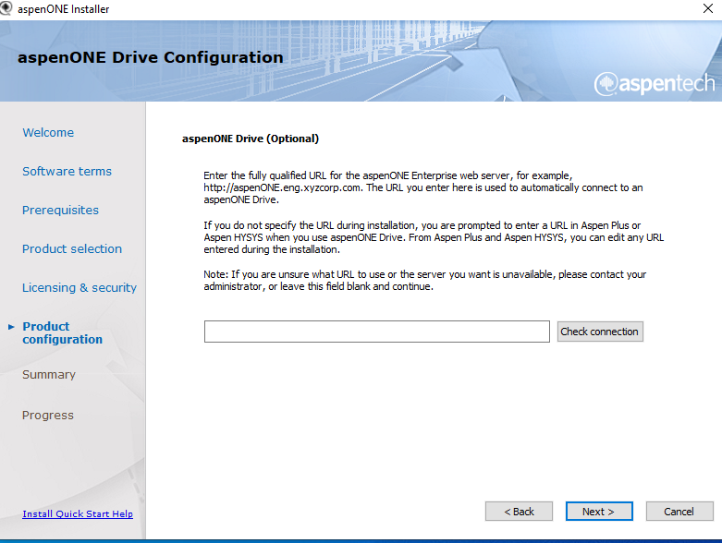

1. “Verify installation file location” and click on “Install” Button.

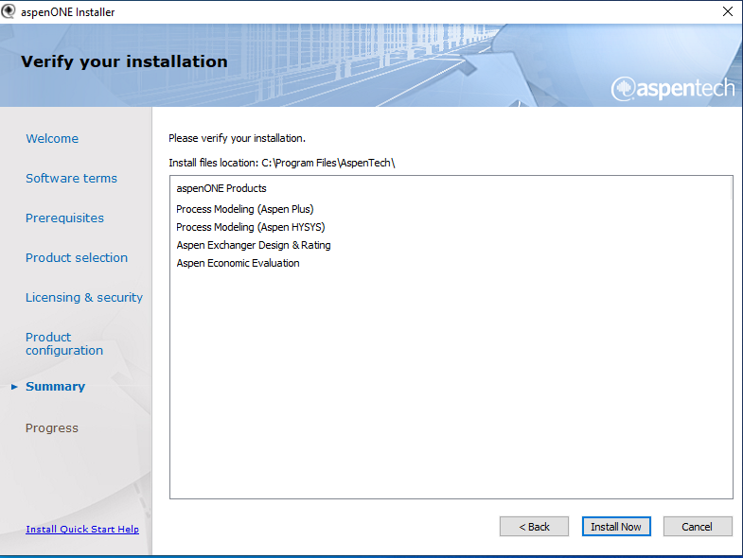

1. The installer will proceed to complete the installation wait a several minute.

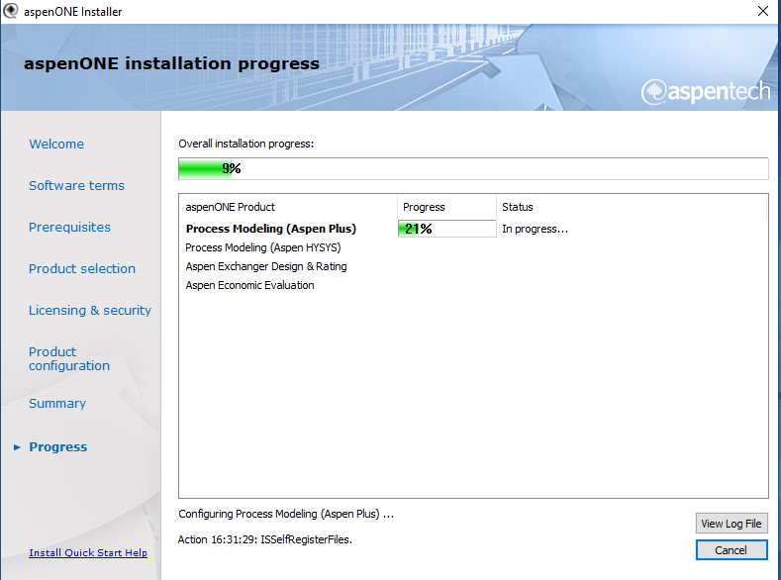

1. “The Installation has been completed” .click on “Finish” button.

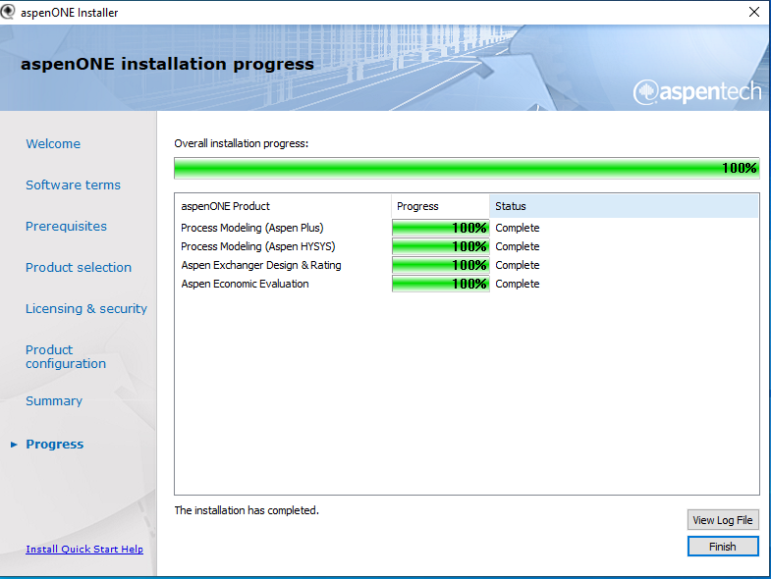

1. Click on the “Reboot Now” Button.

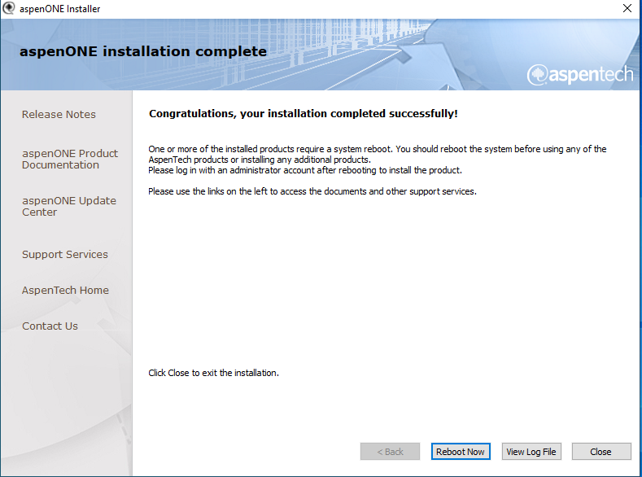

1. Preview for aspenONE are:

